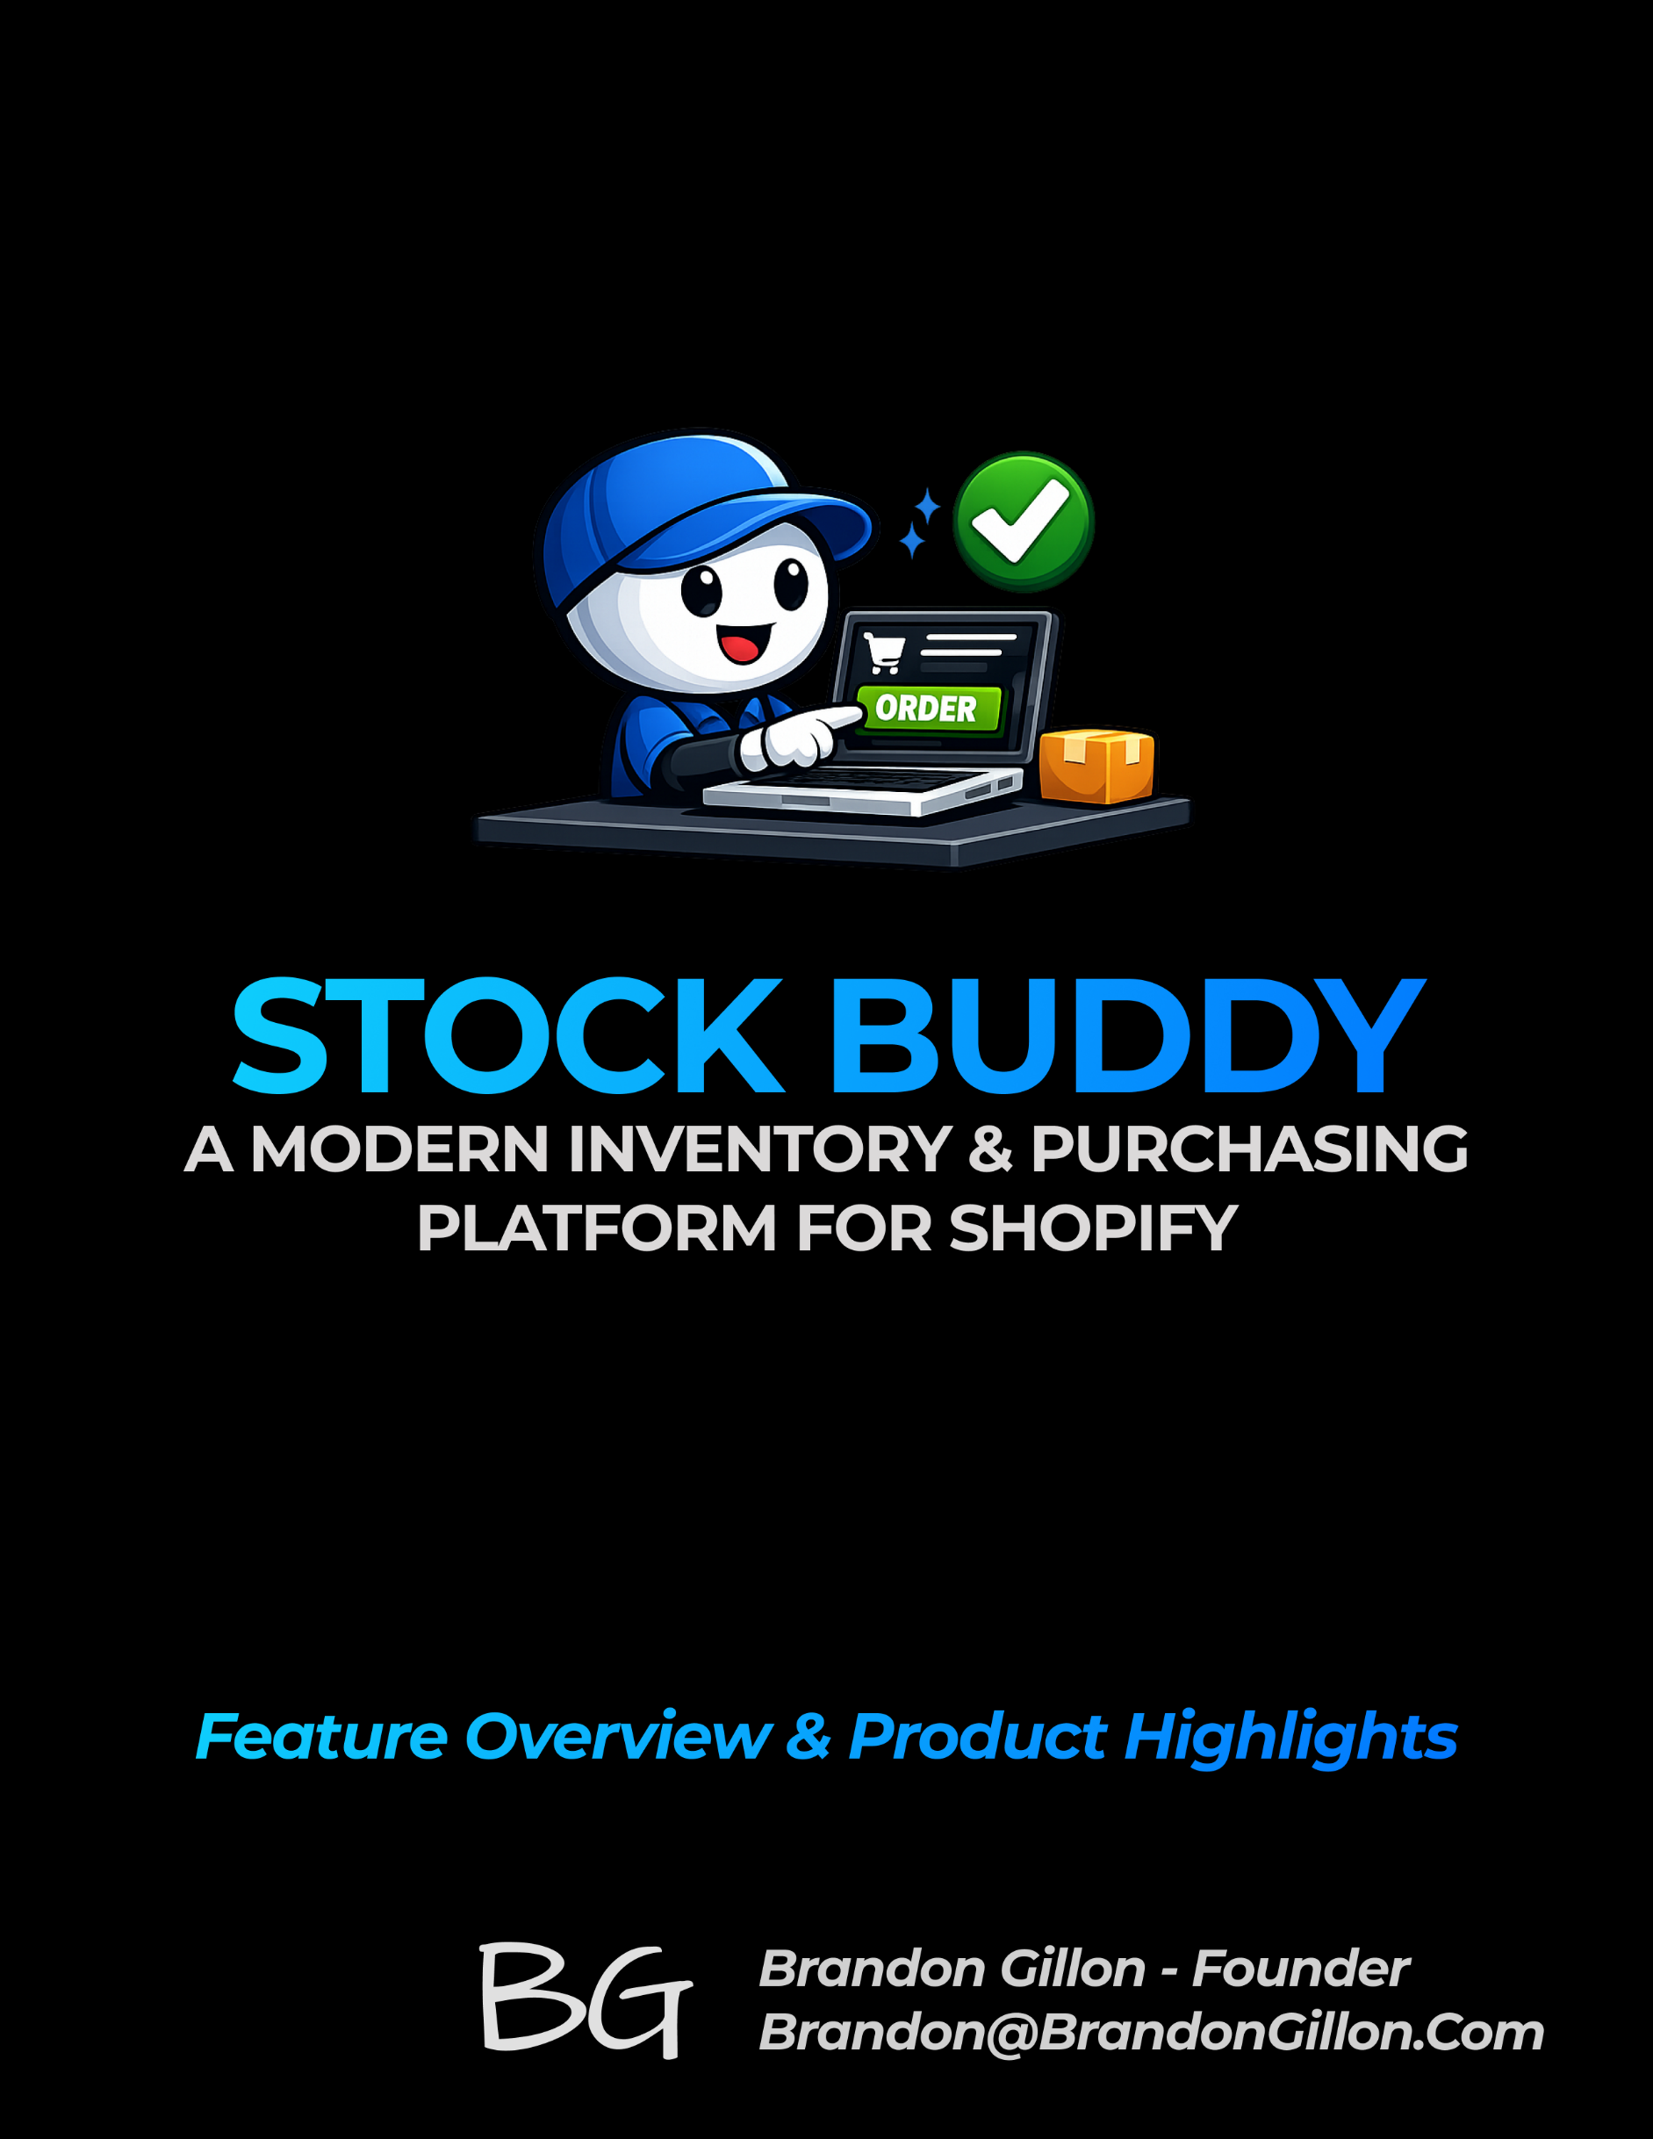

Products All Products
For Stocky, this is in Inventory Products
Feature | Stock Buddy | Stocky | Notes
Lists All Products | ✅ | ✅ | —
“All” Tab | ❌ | ✅ | Stock Buddy uses a single unified Products page instead of tabs.
“Bundles” Tab | ❌ | ✅ | —
Search | ✅ | ✅ | Stocky searches only Title, SKU, Barcode, Vendor. Stock Buddy searches all fields.
Product Import | ✅ | ✅ | Stock Buddy imports all fields; Stocky imports one field per file.
“Add Product” Button | ❌ | ✅ | Stocky links to Shopify’s Add Product page.
Open Product Details | ✅ | — | Stock Buddy opens details by clicking anywhere in the row.
Chevron Menu | ✅ | ✅ | Stocky shows only “View on Shopify”; Stock Buddy uses an arrow button.
Filters | ✅ | ❌ | Stocky has no filter capability.
Export | ✅ | ❌ | Stocky has no export function.
Column Control | ✅ | ❌ | Stocky displays fixed columns only.
Pagination | ✅ | ❌ | Stocky does not paginate.

Products All Products Open Product Details
Feature | Stock Buddy | Stocky | Notes
Product Details Section | ✅ | ✅ | Stock Buddy includes additional metadata fields such as Description, Category, Collection, Shopify ID, and Status.
Variant Records | ✅ | ✅ | Stock Buddy includes Price, Compare At Price, Inventory Qty, Tabbable, and Backorder Allowed.
Variant Column Control | ✅ | ❌ | —
Create Variant | ✅ | ✅ | Both link to Shopify’s Add Variant page.

Products All Products Supplier Product Data
Functionality | Stock Buddy | Stocky | Notes
Manual Editor | ✅ | ❌ | Stock Buddy allows searching by Supplier, Category, and Collection.
CSV Upload | ✅ | ✅ | Stock Buddy supports full-field imports; Stocky imports one field per file.
CSV Sample Download | ✅ | ❌ | —
CSV Instructions | ✅ | ❌ | —
Supported Import Fields List | ✅ | ❌ | —
Supplier Selection | ✅ | ❌ | —
Unknown Item Handling | ✅ | ❌ | —
Case Pack / Inner Pack | ✅ | ❌ | Stocky only supports a single “Pack Size” field.

Inventory
Functionality | Stock Buddy | Stocky | Notes
Global Inventory View | ✅ | ❌ | A unified page showing all variants across all locations.
Multi-Location Breakdown | ✅ | ❌ | Expandable per-variant rows showing inventory by location.
Variant-Level Summary | ✅ | ◐ | Stocky shows limited totals but not full variant-level summaries.
Cross-Location Totals | ✅ | ❌ | Stocky does not aggregate inventory across locations.
Filters | ✅ | ❌ | Stocky has no filtering capability.
Export | ✅ | ❌ | Stocky cannot export inventory data.
Search Across All Fields | ✅ | ❌ | Stocky search is limited to Title, SKU, Barcode, Vendor.
Pagination | ✅ | ❌ | Stocky does not paginate inventory tables.
Column Control | ✅ | ❌ | Stocky uses fixed, non-customizable columns.

Locations
Functionality | Stock Buddy | Stocky | Notes
Global Locations View | ✅ | ✅ | —
Add Contact Info | ✅ | ❌ | Stocky does not store or display contact information for locations.
Display Contact Info on List | ✅ | ❌ | Stock Buddy shows phone, email, and primary contact directly in the list.
Display Additional Info | ✅ | ❌ | Stock Buddy shows address, type, Shopify ID, created/updated dates, and an inventory summary.
Show Location Inventory Data | ❌ | ✅ | Stocky shows per-location inventory; Stock Buddy shows inventory globally instead.

Suppliers
Functionality | Stock Buddy | Stocky | Notes
Global Suppliers View | ✅ | ✅ | —
Supplier Contact Info | ✅ | ✅ | Contact info appears directly in the suppliers list for both systems.
Show/Hide Supplier | ❌ | ✅ | Stocky allows hiding suppliers; purpose is unclear and rarely useful.
Add Supplier | ✅ | ✅ | —
Manage Products | ✅ | ✅ | Add or edit products associated with the supplier.
View Files | ❌ | ✅ | Stocky supports file attachments for suppliers.
Add New File | ❌ | ✅ | Stocky allows uploading files to a supplier record.

Vendors
Functionality | Stock Buddy | Stocky | Notes
Global Vendors View | ✅ | ✅ | Stocky shows only Vendor Name; Stock Buddy includes Vendor Name, Product Type, # Products, # Variants, Active/Inactive, and Last Updated.
Search | ✅ | ❌ | Stocky has no search function.
Filters | ✅ | ❌ | Stocky has no filter capability.
Export | ✅ | ❌ | Stocky has no export function.
Column Control | ✅ | ❌ | Stocky displays fixed columns only.
Click Record – Variant List | ✅ | ✅ | Stocky shows Product, Variant, SKU, Cost Price, Revenue/Day, ELT, Est. Dep., Available, Ord. Need; Stock Buddy shows Image, Title, Category, Collection, Status, and # of Variants (clickable for deeper detail).
Click Record – Top Card | ❌ | ✅ | Stocky displays sales velocity (“Units sold per week over last 4 months”).
Lead Times | ❌ | ✅ | Stocky supports vendor-level and variant-level lead times.
Re-stock Period (days) | ❌ | ✅ | Stocky includes a restock period field; purpose unclear.
Order Limits | ❌ | ✅ | Stocky includes order limit fields (likely read-only).
Convert to Supplier | ❌ | ✅ | Stocky allows converting a vendor into a supplier.

Settings – CSV Export Field Options
Feature | Default | Editable | Notes
PO Number | Checked | No
Supplier Name | Checked | Yes
Ship To Name | Checked | No
Ship To Address | Checked | No | If this is enabled, it means include all the Ship To address fields (city, zip, etc.)
Line No | Checked | No
SKU | Checked | No
Supplier SKU | Unchecked | Yes
Barcode | Checked | Yes
Title | Checked | Yes | Insert Variant Title, or Product Title instead if Variant Title is null
Quantity | Checked | No | In the CSV, please change the name to "Quantity" instead of "Order Qty Units"
Unit Cost | Checked | Yes
Extended Cost | Unchecked | Yes
PO Date | Checked | Yes
Expected Date | Checked | Yes
Notes for supplier | Checked | Yes
Bin/Shelf Location | Unchecked | Yes | Future Use
Product Tags | Unchecked | Yes
Weight | Unchecked | Yes | We need to a weight field in the db
Total Weight | Unchecked | Yes
Weight Units | Unchecked | Yes | We need to add a weight unit field in the db (LP, KG, OZ, etc.) Not sure the best name for this.
Retail Price | Unchecked | Yes
Current Stock | Unchecked | Yes
Total Stock (All Locations) | Unchecked | Yes

Operating Modes of Stock buddy

The “Big’ Scenarios
# | Name | PO in Stock Buddy? | PO in Shopify? | PO in WMS? | Who Updates Shopify? | Who Updates Stock Buddy? | Description
1 | Stock Buddy is the only PO | Yes | No | No | Stock Buddy | Stock Buddy | Merchant creates PO in Stock Buddy; warehouse has no PO; all inventory updates originate from Stock Buddy.
2 | Shopify also has a PO | Yes | Yes | No | Stock Buddy | Stock Buddy | Merchant created a PO in Shopify (or Stocky did previously) and in Stock Buddy; Shopify’s PO is ignored; Stock Buddy drives all updates.
3 | Warehouse has the PO | Yes | No | Yes | Warehouse → Shopify | Shopify → Stock Buddy | Warehouse receives against their own PO; warehouse updates Shopify; Stock Buddy listens and updates its PO based on Shopify changes.
4 | Warehouse updates Shopify, Stock Buddy listens | Yes | Maybe | Yes or No | Warehouse → Shopify | Shopify → Stock Buddy | Warehouse is the source of truth for receiving; Stock Buddy matches Shopify inventory changes to open POs and updates receiving.

Scenario #1 – PO Only in Stock Buddy
- Description: Merchant creates PO in Stock Buddy; warehouse has no PO; all inventory updates originate from Stock Buddy.

Scenario #2 – PO in Stock Buddy & Shopify
- Description: Merchant created a PO in Shopify (or Stocky did previously) and in Stock Buddy; Shopify’s PO is ignored; Stock Buddy drives all updates.

Scenario #3 – PO in Stock Buddy, Shopify, & WMS
- Description: Warehouse receives against their own PO; warehouse updates Shopify; Stock Buddy listens and updates its PO based on Shopify changes.

Scenario #4 – Need Name!
- Description: Warehouse is the source of truth for receiving; Stock Buddy matches Shopify inventory changes to open POs and updates receiving.

